Roadmap Buying licences
‘step-by-step we’re getting there’
Here is the roadmap for purchasing redundant Microsoft Volume licenses from an Enduser or thru a reseller.
These are the steps that have to be taken and the necessary supporting documents that are required to guide this transaction according to the correct rules (laws and regulations) to a good transfer.
This is the procedure, when an End Users has redundant licences and want to sell them!
Before you take the steps below make sure that:
- You have a signed NDA,
- You have a signed order confirmation, that enables you to be the one that is selling the licences. You can also combine the confirmation of the order and NDA in one.’
- Also important is to know when the licences will be available, sometimes they are redundant already and in some cases they are still in use. This is important to make the estimate for the possible value of the licences.
- Also the first question from a buyer will be, the land where the licences have been used and don’t forget to ask about the applied licence contract. You want to know at forehand, to be sure that it is not an academical or governmental version, because they are very hard to trade and much cheaper to buy in the first place!
‘If you need examples of this, sent me an email and I will sent it to you.
If this is all taken care of, we can start the transfer and keep in mind, that we do the specific work when it comes to the transfer and getting the proper information, so don’t be scared for that, we support you all the way and in many cases we do it ourselves.
We must take the following steps and provide documents:
1. Name and address of the customer, (including the name of the person authorized to sign),
2. A screenshot or scan of the licenses from the VLSC and a printout of the MLS excel-file, (we also have an introduction movi about the MLS on our support page
3. The original purchase invoices/invoices for these licenses,
4. We will have the “Declaration of Destruction” drawn up, which must be signed,
5. If necessary, we should receive a copy of the SA agreement,
6. The supplier can draw up the invoice for the agreed amount for this takeover,
7. After receipt of all necessary documents and payment on our part,
8. The actual transfer of the original license activation codes.

If these above steps have been completed in full, this transaction is a fact.
What is important to reminder is, that a transfer is completed when the buyer paid the formal owner. So the seller is always sure to get this money, because without the payment there is no transaction/transfer. That is also why we let the buyer always pay directly to the seller. We always work with a handling fee as a commission for our work, depending on the quantity this percentage is between 35-25% of the realized turnover.
So this can be a good way of making money for the organizations you work with and for your own business.
In the appendix below I put some documents to give you more ‘inside’ information.
Appendix
2. A screenshot or scan of the licenses from the VLSC (or a printout of the MLS),
The VLSC / Volume Licence Service Center
Below you see an example of the screenshot of the Volume License Service Center, the portal from Microsoft. I can show the details of Royal Imtech NV, because they went bankrupt. In any case this is for internal use only.
In General, the VLSC gives you the information to work with for the ICT department. The MLS shown below, is more like the “ID’ of the company. That tells more about the entities and so on, the VLSC is more for the actual installing and so on and holds the keys and more.
The VLSC portal contains a few tabs and holds the following information:
- Products / Licences Groups
- Contacts
- Licences
- Order Confirmations
- Order renewals
- Instruction SA
Screenshot of the VLSC from Royal Imtech NV
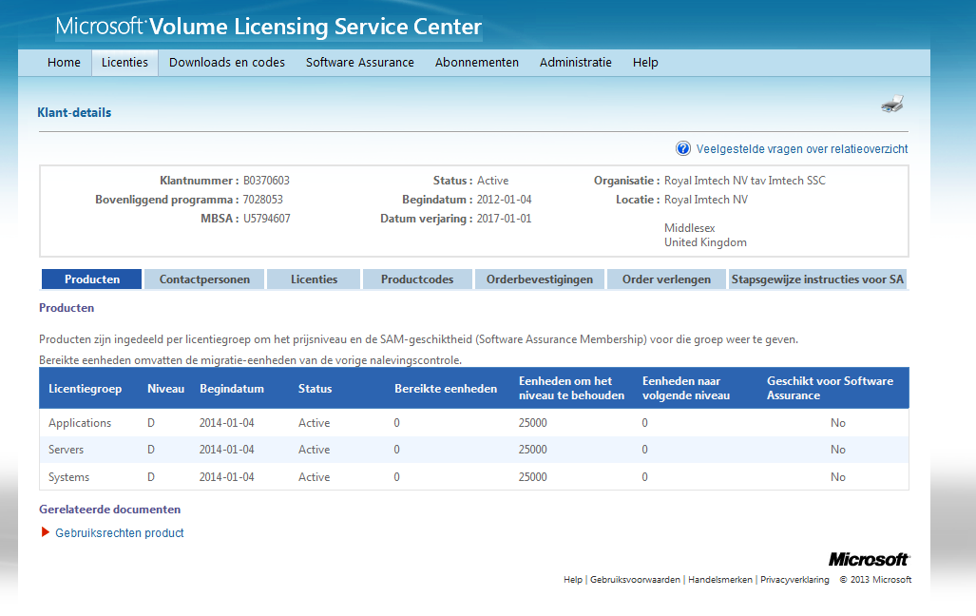

The MLS / Microsoft Licence Statement
The MLS is as we said more like the ID of the company and tells you all the organizations that are involved. The MLS contains a few tabs and holds the following information:
- Organisation Summary,
- License Summary,
- Transaction Summary,
- Licence Agreements,
- Transaction Data,
- and so on.
Screenshot of the MLS from Royal Imtech NV
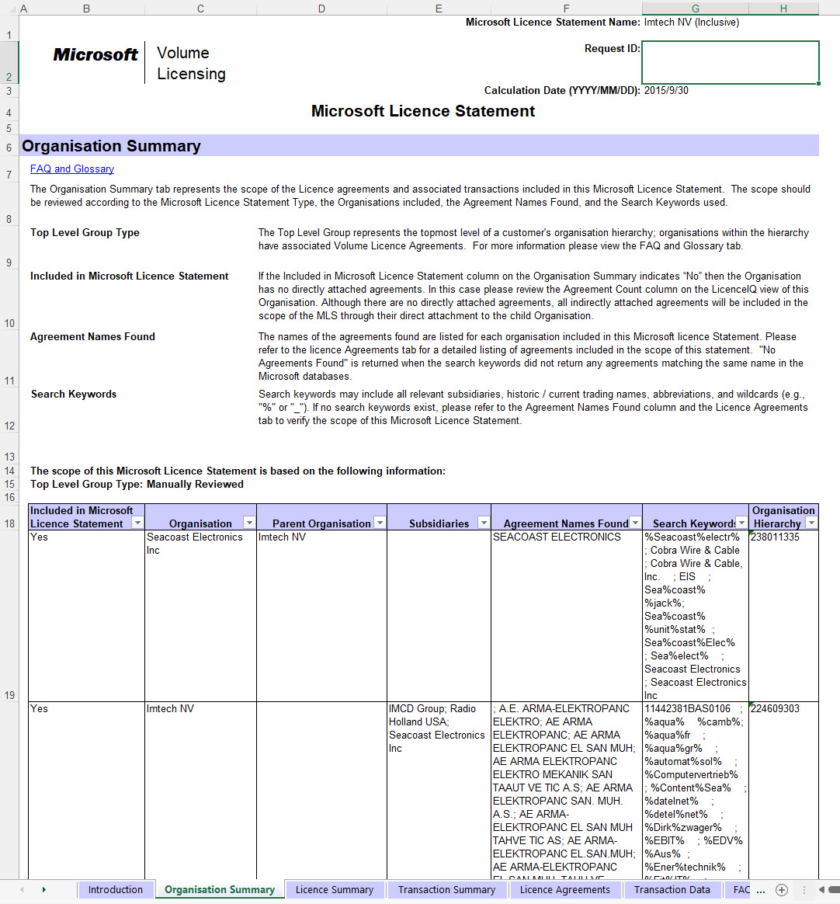
This is a link to the infomercial about the MLS.
4. We will have the “Declaration of Destruction” drawn up, which must be signed,
The so called ‘Declaration of Destruction’
This is a statement, that the licenses have been uninstalled from the original owner and are no longer used and in fact redundant.
Below you see an example of a letter of destruction.
Declaration of Destruction Software Licenses
Name of the seller: ******
Seller's address: Representative: ******
Position of the sales representative: ******
According to the highest court jurisdiction of the Court of Justice of the European Union (ECJ, judgement of 3-7.2012 - C-128/11) and the following of the German Federal Court of Justice (BGH, judgement of 17.7.2013 - I ZR 129/08; BGH, judgement of 11.12.2014 - I ZR 8/13) as well as according to the Swiss jurisdiction (KG Zug, ES 2010 8221 order of 4 May 2011) the sale of a standard software is subject to certain conditions.
(as a result of so-called exhaustion) is legally possible without requiring the consent of the manufacturer. The present declaration ensures that the seller has rendered his copies of the computer program unusable with regard to the object of purchase at the latest at the time of resale, so that the buyer and any other subsequent purchasers can successfully invoke the (statutory) right of use or the software license for this copy of the program in accordance with the case law.
Against this background I, as legal representative of the above mentioned company, hereby truthfully declare the following and guarantee the correctness of the information as proof in the context of the sale: The computer programs listed below and the associated software license are our unrestricted sole property within the meaning of the above-mentioned jurisdiction.
1). all software copies of the computer programs listed below and purchased on the basis of the designated contract as well as the associated software licenses including backup copies as well as any original data carriers to the extent specified provided on the basis of the specific contract were destroyed in our company at the latest upon delivery of the above invoice and corresponding installations were uninstalled or otherwise rendered permanently unusable.
2). From the time of delivery, the computer programs listed below and the associated software licenses shall no longer be used in any way in our company. Employees are neither allowed nor allowed to use the software any further.
The computer programs listed below and/or the associated software licenses are no longer used or otherwise claimed as a basis for updates.
Pos | Product / Version |  | quantity (total)
1 | (example)RDS User  50 stück  50 stück  50 stück  50 stück  50 stück  19 stück | CAL 2019  *****-*****-*****-*****-*****  *****-*****-*****-*****-*****  *****-*****-*****-*****-*****  *****-*****-*****-*****-*****  *****-*****-*****-*****-*****  *****-*****-*****-*****-***** | 269

Place, Date Signature of the seller
Do you have questions or need my assistance?
Mischa Hulsing
+31 6 34 777 169
m.hulsing@licencepro.nl

