LICENCEPRO  THINK OUTSIDE THE BOX | Tailor-made solution within your budget and the legal possibilities LicencePro your European Licensing Partner

We provide a tailor-made solution within the budget and the legal possibilities.
LicencePro is your European partner.

FACTS
+ 128 Microsoft Licensing Products Available
+ 10 M. euro Turnover in 2021
+ 1,500 Satisfied Customers in Europe
Active in more then 10+ European countries
Active for more then 9 years
Perfect Track-record

Who we are
LicencePro was founded in The Netherlands in the year 2015 and specialized in the trading of redundant Microsoft volume licences.
Based on the ruling of the European Court of Justice of 2012 between Oracle and UsedSoft, it became possible to trade volume licences.
At this moment we are represented in over 10 European countries and the United Kingdom. You can already use our services in the following countries: The Netherlands, Belgium, Spain, UK, Poland, Bulgary, France, Sweden, Romania, Bulgaria, Sweden and the Czech Republic.
LicencePro initially specialized in redundant Microsoft licenses with a mission to help its customers reduce licensing costs without compromising compliance.
In recent years, we have further expanded our services and we also offer: Cloud and hybrid Cloud solutions.
Our goal is that every subsidiary of LicencePro is a Microsoft Partner at the end of 2022.

Our Mission
Our in-depth knowledge of Microsoft licensing products makes LicencePro the ideal partner to answer all your questions about Microsoft licenses, or: providing used MS licenses, cloud computing services, management services software assets or technical support for licensing.
We can help you reduce your customers' overall Microsoft licensing costs, thereby increasing your own margins.
We have the Microsoft experience, purchasing channels, inventory and know-how we want share with privileged partners.
In general you can say that our mission is as follows:
- We supply on-premise solutions with savings of up to 70%,
- We supply hybrid cloud solutions with savings of up to 40%
- We supply cloud solutions at competitive rates
- We have our own Microsoft consultants, for expert advise
In short: One-stop-shopping with the best proposition within your budget.

Our Services

1
On-premise (Redundant) Microsoft licences
LicencePro buys and sells (redundant) volume licenses

2
SAM
Diagnosis and analysis of surpluses and shortages in Microsoft licenses
3
Cloud / Hybrid Cloud
Microsoft cloud and hybrid cloud solutions with potential for significant, recurring savings

(Redundant) Microsoft volume licences

- We offer (redundant) Microsoft volume licenses to meet your customers' needs. We stock a wide range of the latest and previous versions of Microsoft Office, Windows Server, SQL Server and other products, with no minimum order requirements.
- We also offer licences, such as Microsoft Office 2016, that are no longer available for purchase through Microsoft's standard channel.
- Licenses are not subject to wear and 'used' licenses can save up to 70% in comparison to new licenses. This allows your customers to realize substantial savings.
- Top 10 bestselling products: Microsoft Office 2019 / 2016 Professional, Windows 10 Professional, RDS User/Device CAL 2019 / 2016, Windows Server 2016 Std. 16 Core, Windows Server 2016 User/Device CAL, SQL Server 2017 Std. 2 Core and SQL Server User/Device CAL.

SAM
(software asset management)

- Incompliance can pose a significant risk to your customers and most of them will have to undergo a Microsoft Software Asset Management (SAM) audit at some point.
- We can assist you or your client with a SAM audit or perform a pre-SAM audit to identify any non-compliance issues.

- You'll benefit from a team of Microsoft Certified Solution Specialists to support your customer engagements and help you win business.

- We can help you find the best Microsoft licensing solutions for your customers and give you priority access to our tools and simplified product guides for each Microsoft product.

- All of our services are covered by our professional liability insurance.

Cloud / Hybrid Cloud

- Some of your business applications will be more cost-effective and efficient in the cloud, while legacy applications or those dealing with highly sensitive data will be better preserved with on-premise solutions. of our services are covered by our professional liability insurance.

- Our hybrid cloud solutions allow you to enjoy the benefits of a cloud platform while deploying certain applications in an on-premise environment.

- Through the hybrid cloud, we offer users the option to opt for more affordable subscription models without Microsoft Office on-premise rights. In this way, savings can be made with O356 and Microsoft Office by taking advantage of additional O365 services.

- Our hybrid cloud offer allows you to keep your on-premise options while benefiting from the additional advantages of cloud services.

Our Cycle of Activities

SAM AUDIT
Friendly audit, identification of license shortages and surpluses
Purchase/Takeover
Purchasing redundant licences

Cloud / Hybrid Clous
Microsoft subscription licenses (Cloud) / Combination on-premise and Cloud
Sale
Selling (redundant) volume licences

Our Method
Signature of a confidentiality agreement with the Partner/Client
Purchase or sale of redundant licences

Subscription to Microsoft Cloud and/or Hybrid Cloud Solution
Signature of a confidentiality agreement with the Partner/Client

4
2
1
3

CASE 1
Case 1: SAM Intervention and sale of redundant licences to reduce the shortage
Organization: Hospital in the Netherlands
Number of employees: 7,700
Needs
1. The hospital is expected to enter into a new 3-year contract in 2021
2. The hospital must choose between: on-premise, cloud or hybrid cloud
3. Full O365 investment is 3 million
4. The investment over 3 years of the current licences amounts to 2.3 million
Situations
1. No Cloud (yet); it can still be applied (in part), if necessary. Investing in the Cloud now means that the hospital will pay for what is not (yet) used for a longer period of time until the Cloud is actually implemented.
2. Renewing on-premise licenses is too expensive and staff are currently using older versions.
3. Alternatives must be sought and studied.

Findings
1. The SAM study recommends consolidating the investments already made, by means of SA contracts via MPSA for 3 years.
2. Shortage arisen or present due to the non-renewal of the ESA could be completed in the most economical manner.

Results
1. Organization chooses to purchase 700 x Microsoft Office Pro Plus 2019
2. The organization chooses to extend the SA, by renewal via MPSA. Cost of the new contract in year 1: €700,000 - year 2 and 3: €580,000 each.
3. Total investment via second-hand & MPSA over 3 years: €1,860,000. This translates to a saving compared to the Cloud is €1,100,000 and compared to on-premise is €440,000

CASE 2
Case 2: SAM Audit and Surplus Licence Purchase
Organization: Hospital
Number of employees: 2,200
Number of licenses: 2,200
License year: 2008 to 2016
License types: Office Professional Plus, RDS Call, Windows Server Call, Windows Server, SQL Server. Core Call. Windows XP / Windows 7
At the time of expansion, or planning for major infrastructure maintenance and modifications, there was no active Microsoft contract providing rights to the latest version. This led to the following considerations:
1. Is it necessary to migrate to the cloud?
2. What is the physical impact of the infrastructure upgrade on the organization?
3. What is the investment required to replace the equipment?
4. What investment is needed in software/licence renewal?

The licensing consultants and the hospital have come to the conclusion that buying redundant licenses in the correct versions was more beneficial, both financially (lower costs) and operationally.
The investment in new licenses via the standard Microsoft contracts would have amounted to €531,000 while the redundant Microsoft licences Microsoft amounted to €153,000.
Microsoft has decided to perform a pre-delivery audit of the software/licenses. This check was carried out by means of an e-mail containing a link to download the proof of purchase. The hospital then uploaded the retailer's delivery note and invoice and provided the correct information to meet Microsoft's requirements and no further audits followed.

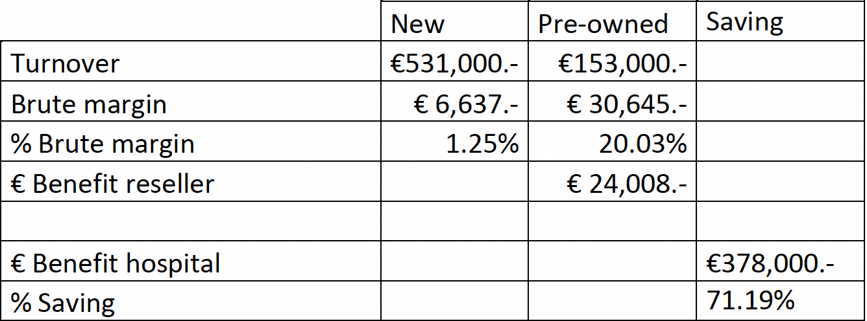
CASE 3

Case 3: Migration to Hybrid Cloud
Organization: Government Organization
Number of employees: 1,800
Number of licenses: 1,500
License year: 2016
Need (tender): Online Office / Collaboration tools / Full Office Suite for offline deployment

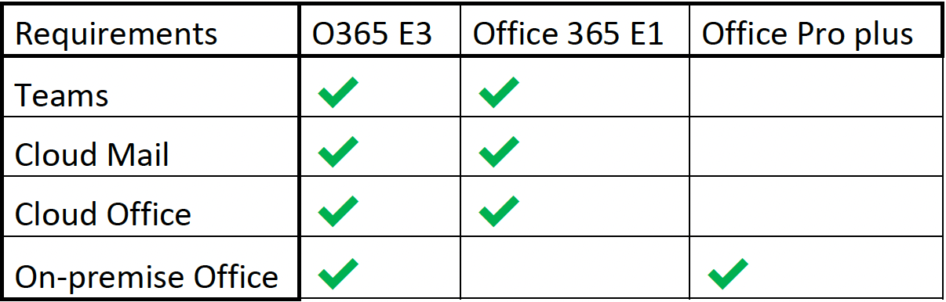

For this customer, the savings made over a period of 3 years is: € 294.76 per FTE!
Total: 1,500 X €294.76 = €442,140
LicencePro won the tender with a sale price lower than the new Microsoft contract or direct prices. This concerned:
- Network management
- Implementation services
- Acceptance & training on O365
- Support Services

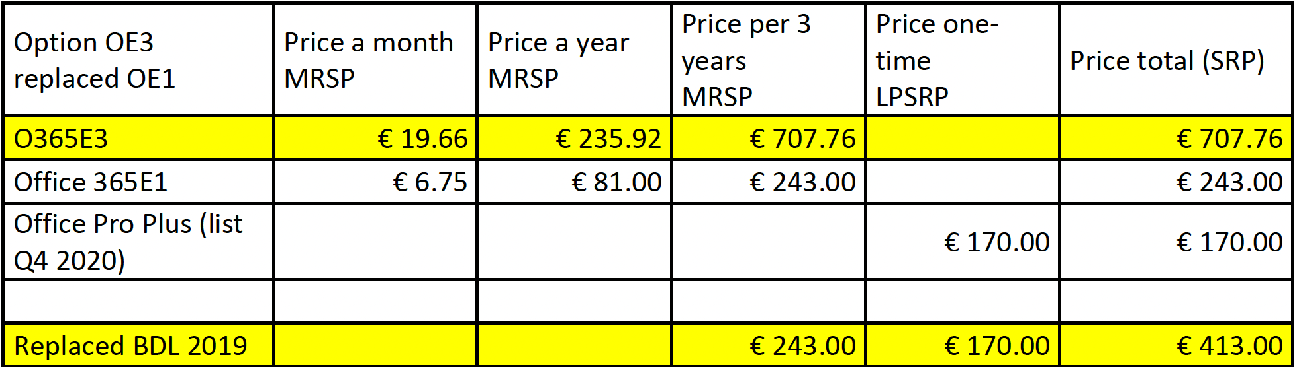

Our references

For confidentiality reasons, we cannot share the names of clients/partners who have given explicit approval.

Any questions?

Your name
Directeur LicencePro
email @licencepro.x
Office: +
Mobile: +

